Practice Problems Section 3 Solutions

1. A point charge $q$ is placed at the center of a spherical surface. The total flux through the surface is Φ. In terms of Φ, what is the total flux through the surface if (**in each case you MUST justify your answer briefly with an equation and/or words**)
   1. the charge is tripled to $3q$?

Gauss’ law states that the total flux through a closed surface is directly proportional to the charge enclosed. Since there is now three times as much charge enclosed, the flux must be three times as large. Therefore

* 1. the volume of the sphere is doubled?

Gauss’ law states that the total flux through a closed surface is directly proportional to the charge enclosed. The charge enclosed has not changed! The volume of the closed surface has no effect on the total flux through the surface. Therefore

* 1. the surface is changed to a cube?

Gauss’ law states that the total flux through a closed surface is directly proportional to the charge enclosed. The charge enclosed has not changed! The shape of the closed surface has no effect on the total flux through the surface. Therefore

* 1. the charge is moved outside the surface?

Gauss’ law states that the total flux through a closed surface is directly proportional to the charge enclosed. The charge enclosed has become zero! Therefore,

$$Φ_{new}=0$$

$$Φ_{E}=\oint{\vec{E}·d\vec{A}=\frac{Q_{\text{encl}}}{ϵ_{0}}}$$

$\vec{r}={\vec{r}}_{f}-{\vec{r}}_{s}$ $\hat{r}=\frac{\vec{r}}{r}$ ${\vec{E}}_{point}=\frac{1}{4πϵ_{0}}\frac{q}{r^{2}}\hat{r}$ ${\vec{F}}_{on q_{0}}=q_{0}\vec{E}$

1. 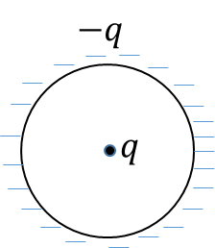A point charge *q* is located at the center of a spherical shell of radius *R*. The shell itself has a total charge *–q* (i.e. a total charge equal and opposite to the point charge at the center) uniformly distributed on its surface. (Except for the point charge at the center, the sphere is hollow).

First draw a picture of the problem based on the description! See picture to the right.

1. Use Gauss’ law to find the magnitude of the electric field at a point **outside** the shell located a distance *r* from the center. **Show your work and/or explain your answer**.

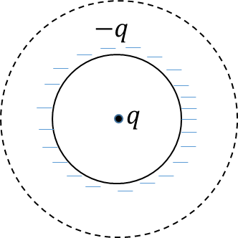Now, to find the field outside, draw a Gaussian sphere with radius $r$ outside of the shell, centered at the center of the shell.

Since the Gaussian sphere is symmetric about the charge distribution, we know that the electric field will be uniform over the Gaussian sphere. In addition, any outward or inward electric field will be parallel to the area vector of the Gaussian sphere. Therefore,

$$\oint{\vec{E}∙d\vec{A}=\oint{EdA}=E\oint{dA}=E(4πr^{2})}$$

Using Gauss’ Law, this integral is equal to the total charge enclosed. The total charge enclosed includes both the point charge and the shell. Thus,

$$Q_{enc}=q-q=0$$

Using Gauss’ law thus yields

$$E\left(4πr^{2}\right)=0→E_{outside}=0$$

1. Use Gauss’ law to find the magnitude of the electric field at a point **inside** the shell located a distance *r* from the center. **Show your work and/or explain your answer**.

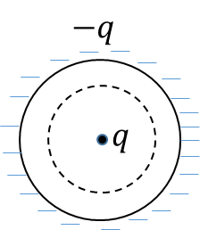

Now do the same thing, but put the Gaussian sphere inside the shell. The calculation of the flux proceeds in exactly the same way.

$$\oint{\vec{E}∙d\vec{A}=\oint{EdA}=E\oint{dA}=E(4πr^{2})}$$

This time, however, the charge enclosed is

$$Q_{enc}=q$$

Since the shell is no longer enclosed by the Gaussian sphere, it plays no part in determining the electric field. Thus, using Gauss’ law, we find

$$E\left(4πr^{2}\right)=q/ϵ_{0}→E_{inside}=\frac{1}{4πϵ_{0}}\frac{q}{r^{2}}$$

Thus, the electric field inside the shell is that of a point charge!